**OLTP (Online Transaction Processing)**

Online Transaction Processing is the information System that typically facilitate and manage the transaction-oriented applications

Basically it the category of data processing that is focussed on transaction oriented tasks

OLTP basically involves the insert update and deletion of small amount of data in the database

OLTP Deals with large number of transaction having large number of users

Example:online banking,atm,order entry , data entry , online shopping etc

In Oltp the schema of database is build up using Entity relation diagram

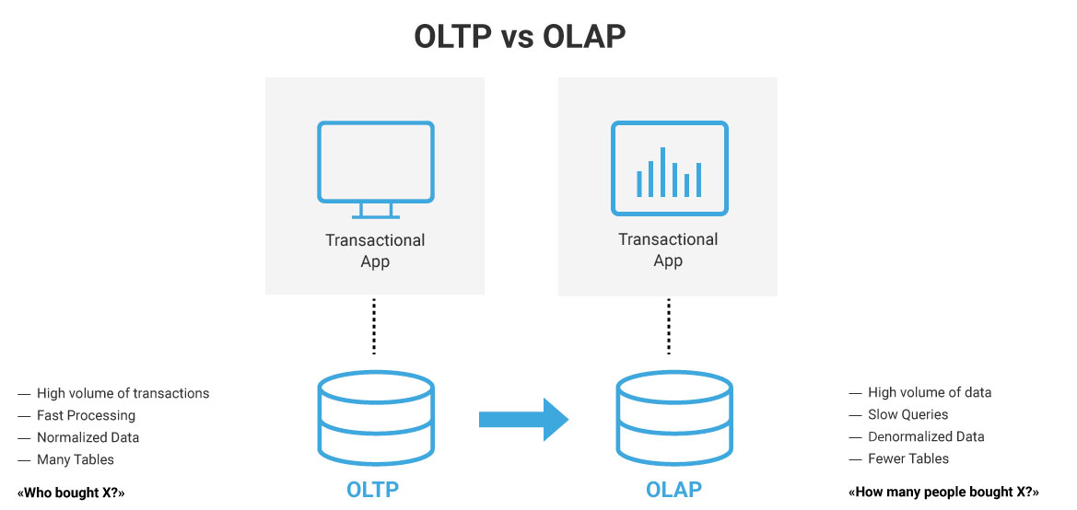

**Online Analysis Processing (OLAP)**

Online Analysis Processing the category of data processing which involves query of many records in data for data analytical purposes

In OLAP we deal with the online data store and access data online session

For example:buk log files are read and written back to data fil

An OLAP banking example could be a bank manager performing a query across all customer accounts, so that he can see which suburbs had the most active online banking customers during a certain period.

OLAP is often used to provide analytics on data that was captured via an OLTP application.

OLTP applications typically possess the following characteristics:

* Transactions that involve small amounts of data
* Indexed access to data
* A large number of users
* Frequent queries and updates
* Fast response times